Name:
Calculator Free | /25 | %
Calculator Assumed | /32 | %
Total | /57 | %
Mathematics Methods, Year 11, 2018
Test 4 – Sets, Probability and Counting.
25 minutes working time.
Calculator Free Section (no notes, no calculators)
SCSA Formula sheet allowed
Question 1 [4 marks: 1, 1, 2 ]
a) Calculate 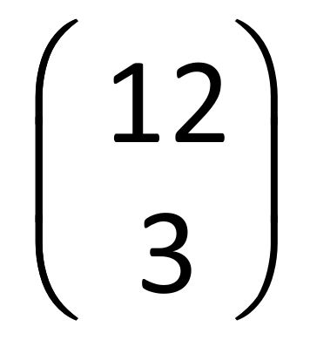

b) Calculate the value of the variable in each of the following:
(i) $\left(\begin{matrix}n \\ 4\end{matrix}\right)=\frac{15!}{11!×4!}$

(ii) $\left({{}_{}^{9}C}_{r}^{}\right)=\frac{9×8×7×6}{4×3×2×1}=$

$\left(\begin{matrix}12 \\ 3\end{matrix}\right)=\frac{12!}{9!×3!}=y$

Question 2 [10 marks: 1, 5, 4]
Consider the expansion of (3x – y)⁴ .
- (i) How many terms are there in this expansion?
5

(ii) Expand and simplify the expression, in descending powers of x.

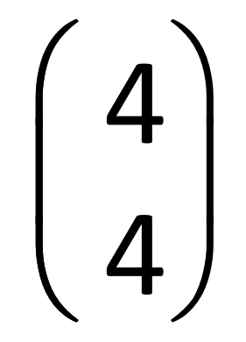(3x)⁴(-y)⁰ +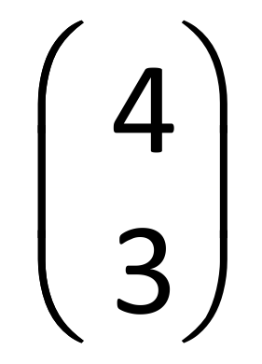(3x)³(-y)¹ +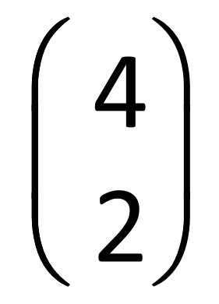(3x)²(-y)² +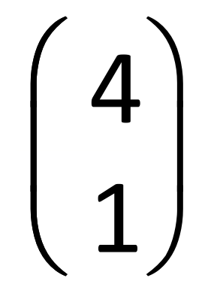(3x)¹(-y)³ +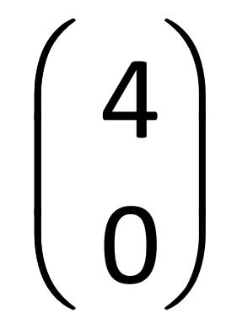(3x)⁰(-y)⁴

= 81x⁴ - 108x³y +54x²y² -12xy³ +y⁴ ^{One per correct term.}

b) State the coefficient of the second term of the expansion of (x²-2y)³ ?
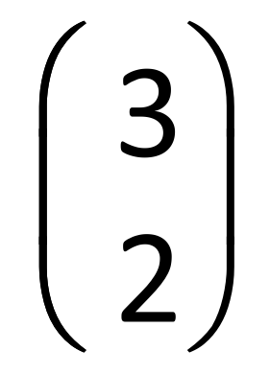(x²)²(-2y)¹
= 3 x⁴(-2y)
=-6x⁴y
The coefficient is -6

Question 3 [3 marks: 1, 2]
- Describe the following shaded region in terms of A and B using set notation.

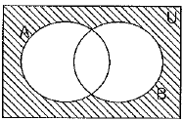

- Shade the following region $\left(A∩\overline{B}\right)$

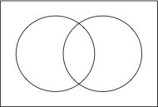

Question 4 [8 marks: 3, 4, 1]
A survey of 56 Year 10 students revealed that the number of students owning a bicycle and scooter was four times larger than the number who owned only a bicycle. The number of students owning a scooter and not a bicycle was 10 less than the number who owned both. Three students own neither a bicycle nor a scooter.
Let x be the number who owned only a bicycle.
- Use the above information to complete the Venn diagram below in terms of x.
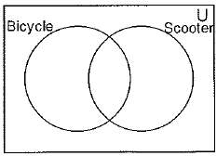

- By solving for x, complete the Venn diagram below, stating the number of students in each category.



x + 4x + 4x -10 + 3 = 56
9x = 63
x = 7
Bicycle = 35, Bicycle and Scooter = 28, Scooter 46.

(c) What is the probability that a student who owned a bicycle also owned a scooter?
P (Scooter given owned a bicycle) = P (Scooter and Bicycle) = 4
P (Bicycle) 5
Name:
Total | /32 | %
Mathematics Methods, Year 11, 2017
Test 3 – Sets, Probability and Counting.
Calculator Assumed Section (notes allowed) 32 minutes working time.
SCSA Formula sheet and calculators allowed
Question 5 [8 marks: 2, 2, 2, 2]
A squad of $12$ cyclists is to be chosen at random from $16$ applicants. $7$ of applicants live in New South Wales, $4$ live in Victoria and the rest live in WA.
(a) Determine the number of different squads that can be chosen. (2 marks)
Solution
$$\left(\begin{matrix}16 \\ 12\end{matrix}\right)=1 820$$

Specific behaviours
indicates use of combination formula
✓ correct number

(b) Determine the number of different squads that can be chosen that

(i) include all the cyclists from Victoria. (2 marks)
Solution
$$\left(\begin{matrix}4 \\ 4\end{matrix}\right)\left(\begin{matrix}12 \\ 8\end{matrix}\right)=1×495 \\ =495$$

Specific behaviours
indicates correct method
✓ correct number

(ii) include an equal number of cyclists from each of the states. (2 marks)
Solution
$$\left(\begin{matrix}7 \\ 4\end{matrix}\right)\left(\begin{matrix}4 \\ 4\end{matrix}\right)\left(\begin{matrix}5 \\ 4\end{matrix}\right)=35×1×5 \\ =175$$

Specific behaviours
indicates correct method
✓ correct number

(iii) have no more than one cyclist from Victoria. (2 marks)
Solution
$$\left(\begin{matrix}4 \\ 0\end{matrix}\right)\left(\begin{matrix}12 \\ 12\end{matrix}\right)+\left(\begin{matrix}4 \\ 1\end{matrix}\right)\left(\begin{matrix}12 \\ 11\end{matrix}\right)=1×1+4×12 \\ =1+48 \\ =49$$

Specific behaviours
indicates correct method
✓ correct number

Question 6 [10 marks: 5, 1. 2. 2]
An analysis of new cars sold recently showed that 80% had automatic transmission (event A) and that 68% were classified as having a small to medium sized engine (event S). It was also noted that 56% of cars had both automatic transmission and a small to medium sized engine.
- Use the above information to complete all the probabilities in this tree diagram

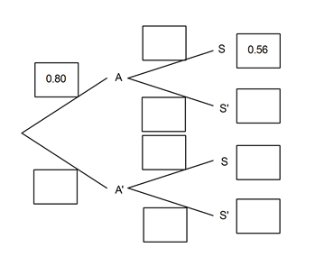

- Determine the probability that a randomly selected car will
- have a small to medium sized engine given that it does not have an automatic transmission.

- have a small to medium sized engine or have automatic transmission.

- have automatic transmission given that it has a small to medium sized engine.

Question 7 [7 marks: 1, 2, 1, 1 2]
The probabilities of two events A and B are such that P(A) = 0.55 and P(B) = 0.3
Determine:
- The minimum value of P(A∩B).

- By considering your answer to part (a), what can you say about events A and B when P(A∩B) is a minimum. Draw a Venn diagram to illustrate this.

- P(A∪B), using your answer from part (a)

- The maximum value of P(A∩B)

- By considering your answer to part (d), what can you say about events A and B when P(A∩B) is a maximum. Draw a Venn diagram to illustrate this.

Question 8 [8 marks 4, 2, 2]
Events A and B are such that P(A∩B) = 0.3, P(A∪B) = 0.8 and P(A) = 2P(A∩B)
- Use the above information to create a two-way table in the space below.

- Determine P(A|B)

- Are A and B independent events? Justify your answer.

